# **Task 1**

Create a visualization that provides a breakdown between the male and female employees working in the company each year, starting from 1990.

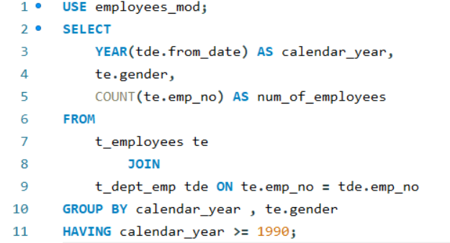

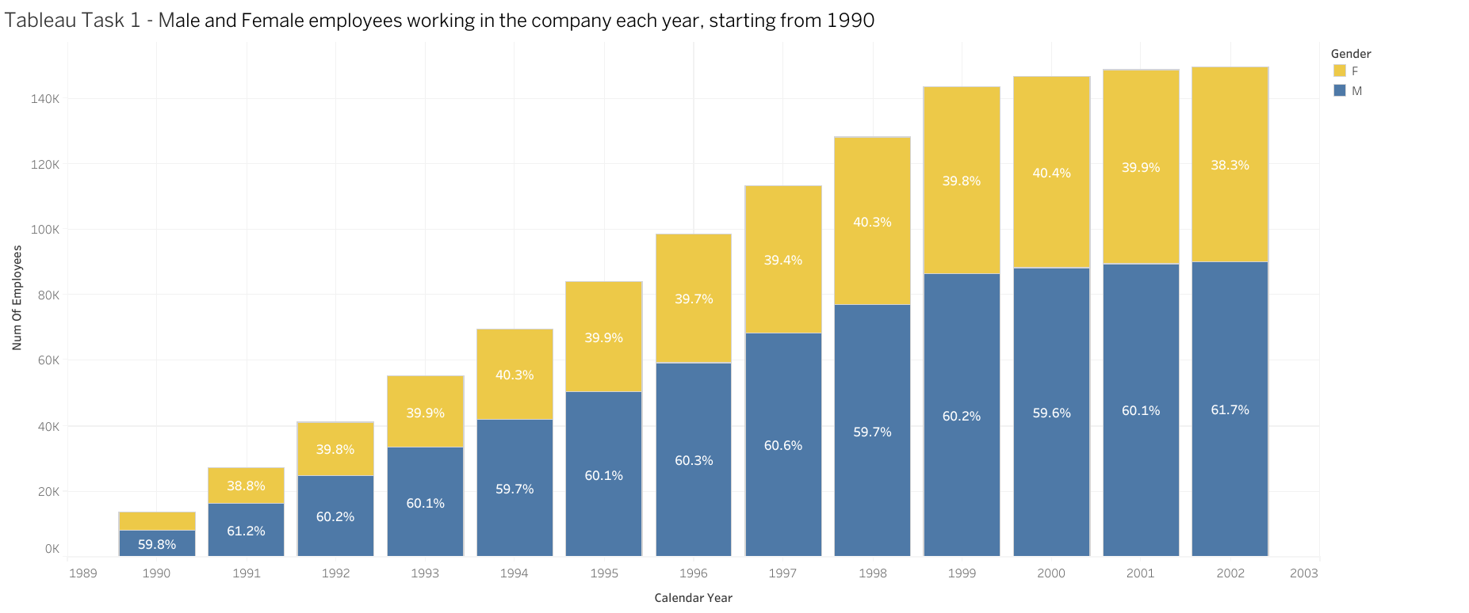

Link : <https://public.tableau.com/views/Book2_17358257931730/Chart1?:language=en-US&publish=yes&:sid=&:redirect=auth&:display_count=n&:origin=viz_share_link>

# **Task 2**

Compare the number of male managers to the number of female managers from different departments for each year, starting from 1990.

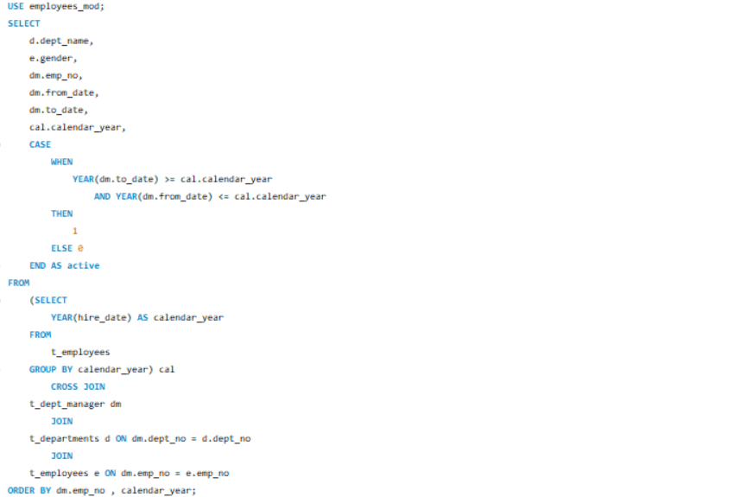

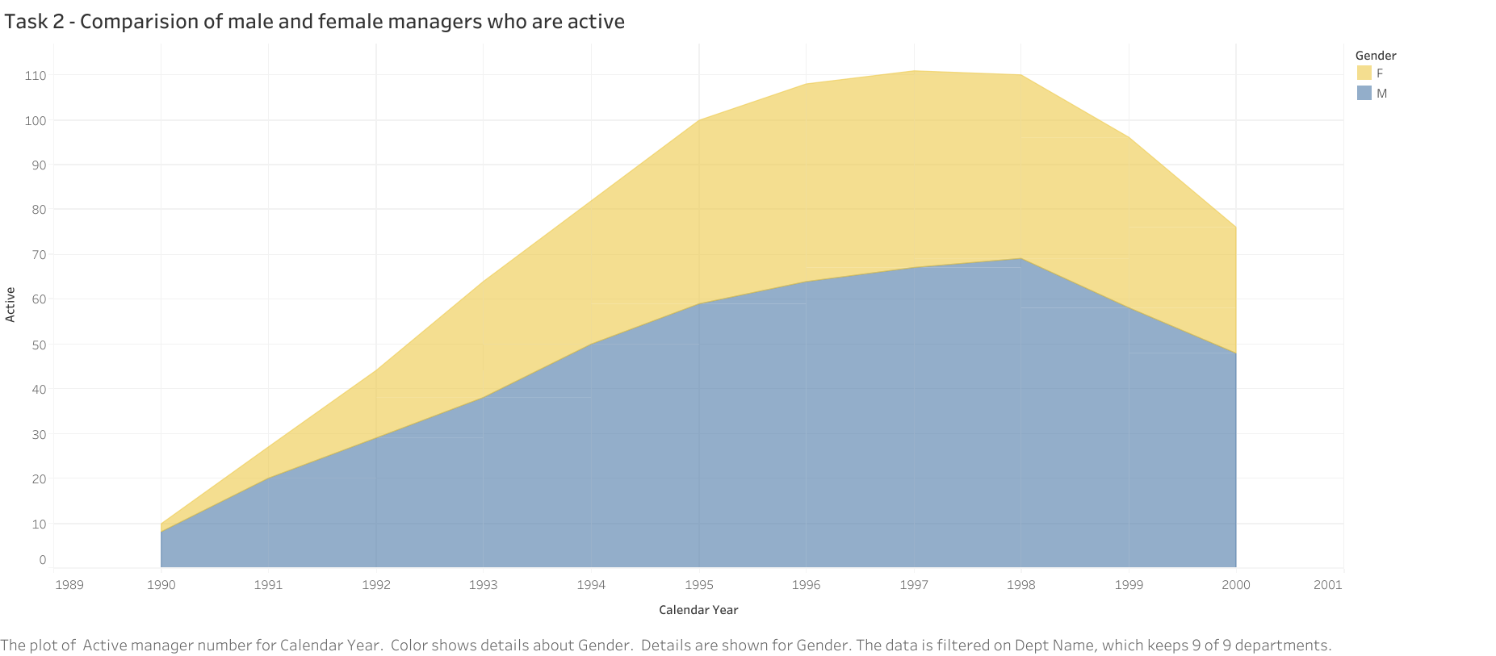

Link: <https://public.tableau.com/views/task2_17359290579960/Sheet1?:language=en-US&publish=yes&:sid=&:redirect=auth&:display_count=n&:origin=viz_share_link>

# **Task 3**

Compare the average salary of female versus male employees in the entire company until year 2002,

and add a filter allowing you to see that per each department.

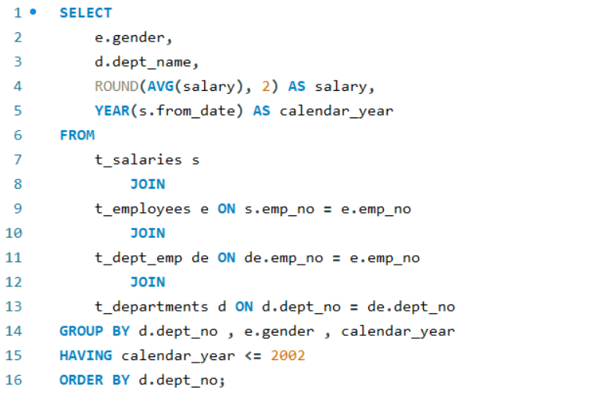

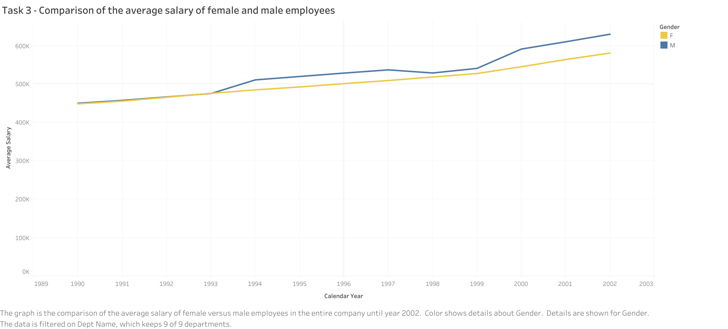

Link: <https://public.tableau.com/views/Task3_17360134926880/Task3?:language=en-US&publish=yes&:sid=&:redirect=auth&:display_count=n&:origin=viz_share_link>

# **Task 4**

Create an SQL stored procedure that will allow you to obtain the average male and female salary per department within a certain salary range. Let this range be defined by two values the user can insert when calling the procedure.

Finally, visualize the obtained result-set in Tableau as a double bar chart.

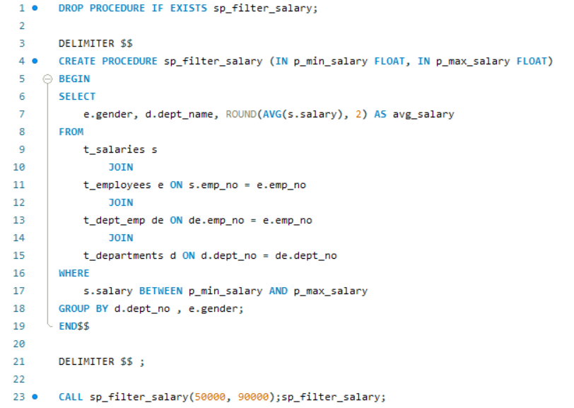

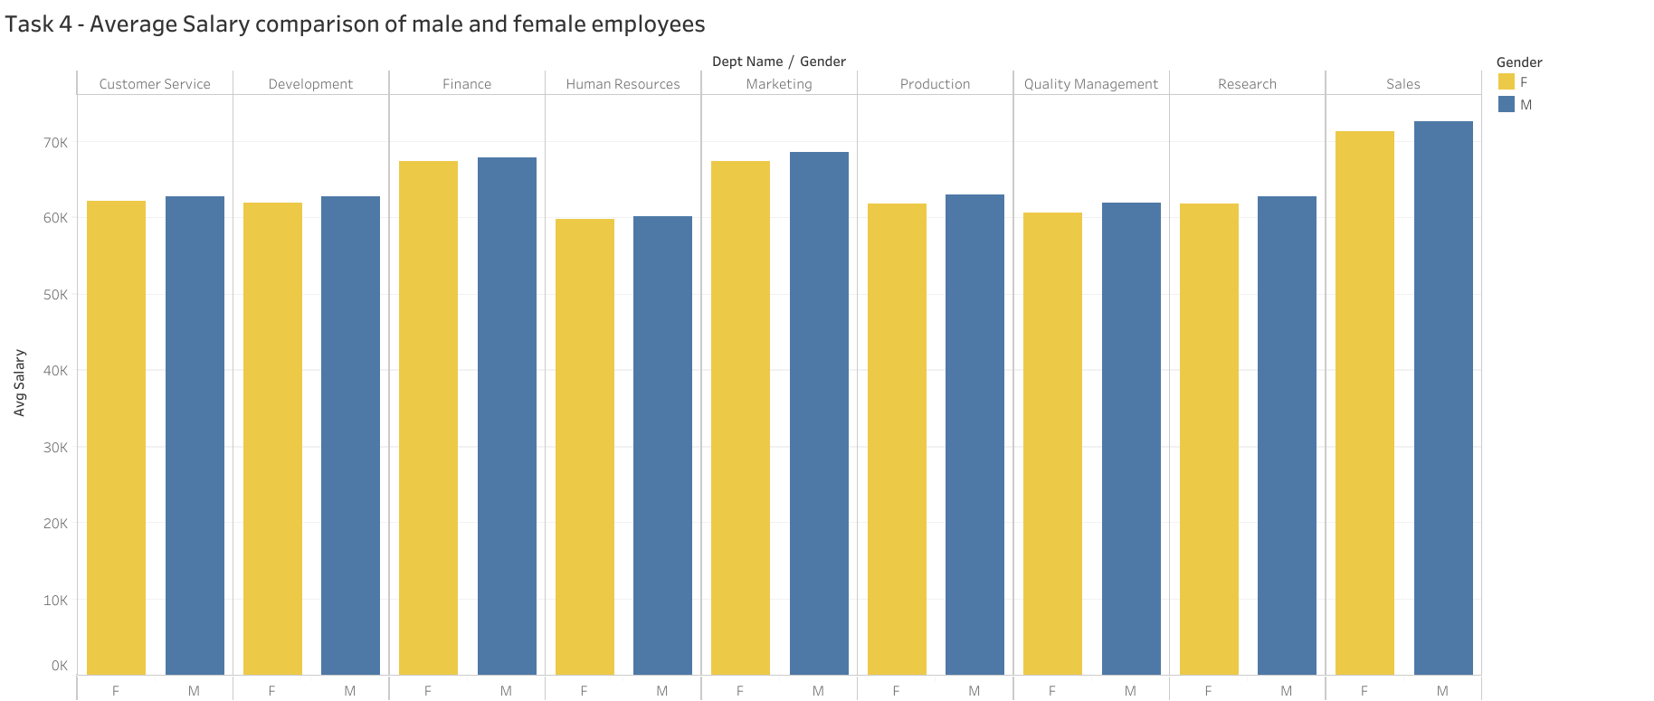

Link : <https://public.tableau.com/views/Task4_17360826774850/Task4?:language=en-US&publish=yes&:sid=&:redirect=auth&:display_count=n&:origin=viz_share_link>

# **Final Dashboard**

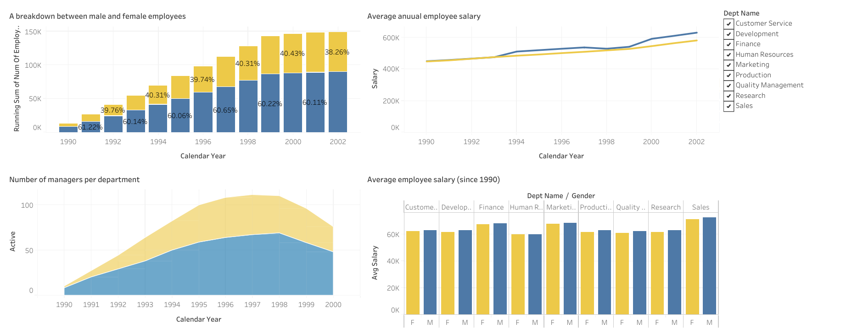

Link: <https://public.tableau.com/views/final_dashboard_17360853681300/Dashboard1?:language=en-US&publish=yes&:sid=&:redirect=auth&:display_count=n&:origin=viz_share_link>